**To create a Webpage using Basic HTML Tags**

<!DOCTYPE html>

<html>

<head>

<title>My First Web Page</title>

</head>

<body>

<center>

<img src="Images/NIEC-Logo.png">

<br>

<hr>

<marquee bgcolor = "Yellow">

This is a marquee Tag and is used to scroll a text or media in a web page.

</marquee>

<br>

<h1>

This is H1

</h1>

<h6>

And this is H6

</h6>

<hr width="50%" noshade size="5">

</center>

</body>

</html>

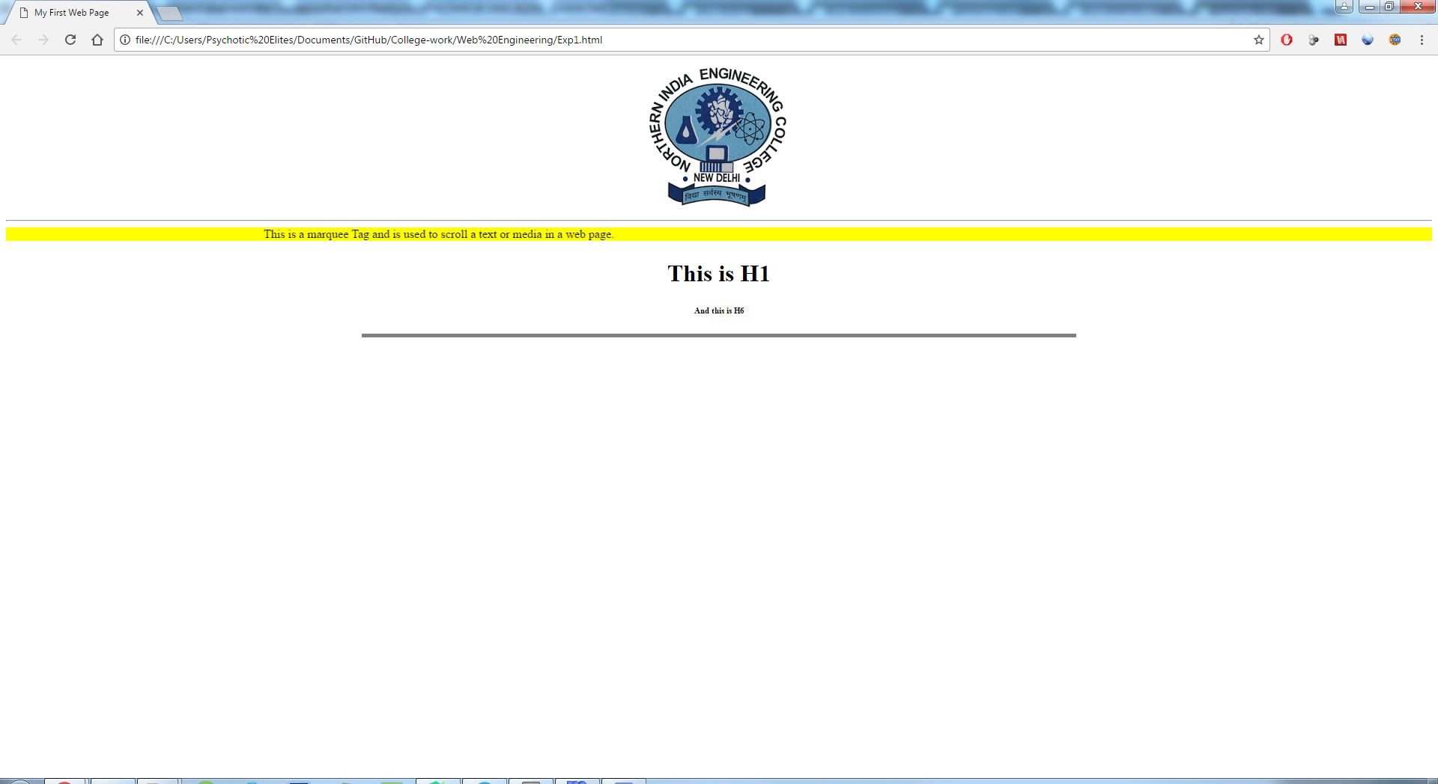

**Webpage made by using basic HTML tags**